New Functionality
Sync Reports for Respective Department Forms
District GIS Parakh | Version 1.0 | User Guide

Overview
This guide describes the Sync Reports functionality available in the District GIS Parakh portal. The Sync Data feature allows State Administrators to synchronize inspection data for department-specific forms, ensuring reports are up to date across the system.

Prerequisite: You must have valid State Admin credentials before proceeding with the steps below.

Prerequisites
• Active State Admin login credentials
• Internet connectivity to access the District GIS Parakh portal
• Relevant department form data available in the system

Step-by-Step Procedure

Step 1 – Log In with Your State Admin ID
Open the District GIS Parakh portal and log in using your State Admin credentials. Ensure you are using the correct account associated with your respective department.

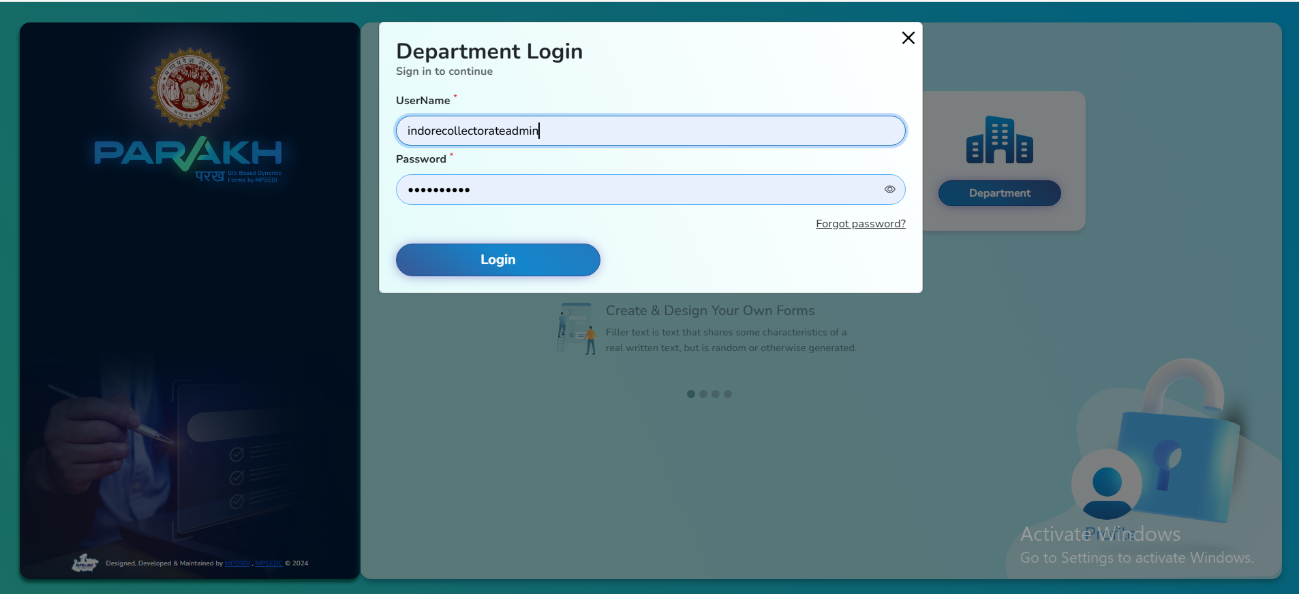

Step 2 – Navigate to Tabular View of Inspection
From the Dashboard screen, locate and click on “Tabular View of Inspection”. Once the view loads, click on the “Sync Data” button to initiate the synchronisation process.

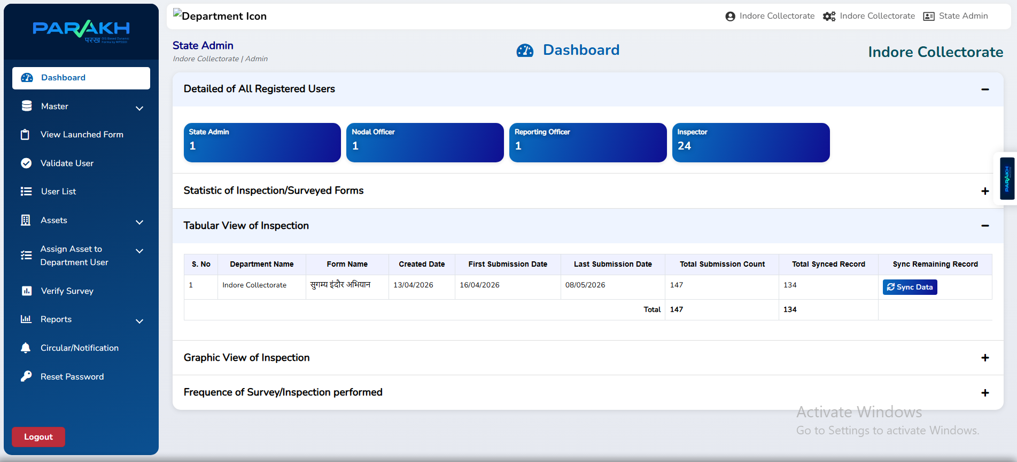

Step 3 – Confirmation of Sync
Upon successful completion, the system will confirm that the data has been synced. The updated inspection data will now be reflected across all associated department reports.

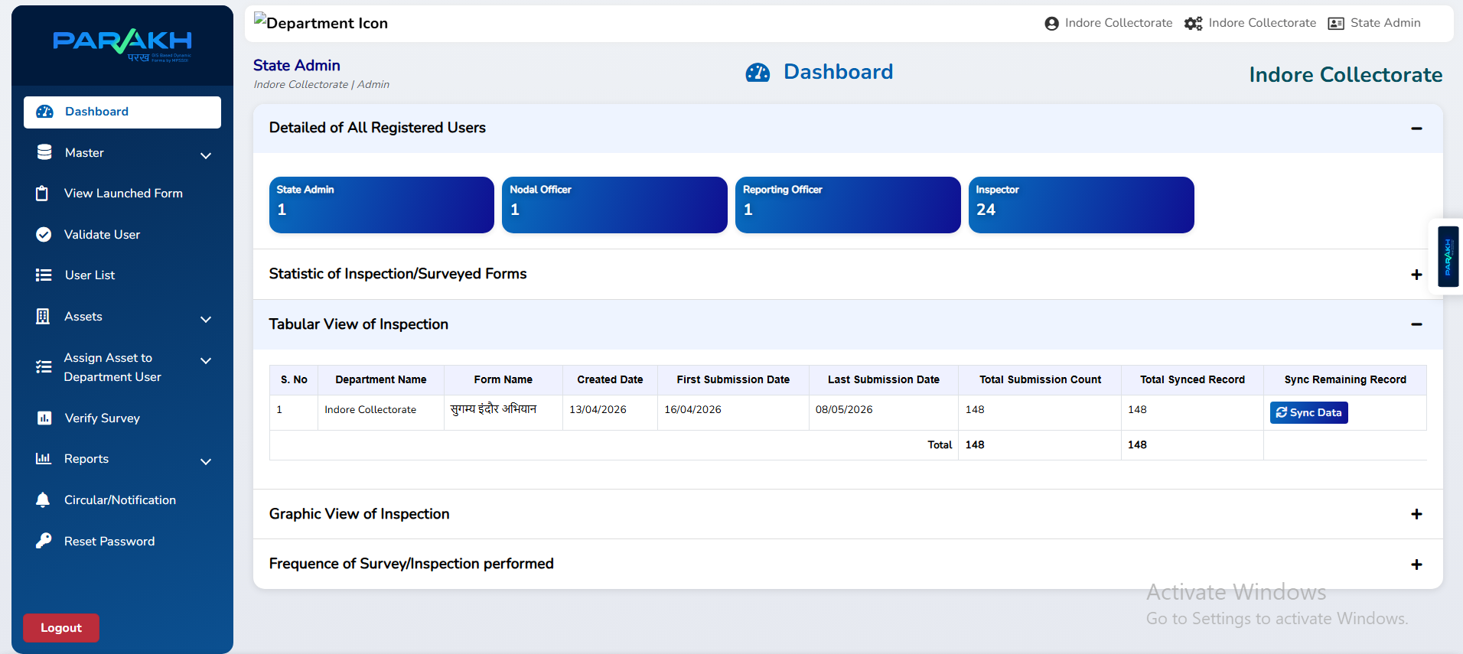

Expected Result
After completing the above steps, the data for the respective department forms is fully synchronised. All associated reports will now display the latest inspection data in real time.

Troubleshooting
If the sync does not complete successfully, consider the following:

• Verify that your State Admin ID has the required permissions.
• Check your internet connection and retry the sync.
• Clear the browser cache and reload the portal before attempting again.
• Contact the system administrator if the issue persists after multiple attempts.

Support
For technical assistance, please reach out to your designated IT support team or the District GIS Parakh helpdesk.

